Issued by: | Roxanne Cabigting/Katherine Masangkay | Date Approved:
Approved by: | Mark Jhevan Mendoza

JOBTRACK REQUIREMENTS
Document

- Objective
Established workflow management for AUNZ End-to-End Looseleaf processing.
- Audience
The target audiences of this document are the project teams of both Straive and LN.
- Documents Referenced
- LN Pub Tracker
- Scope
- Commentary
- Legislation (import tracker only)

COMMENTARY

2.2 Requirements
The primary required features of the application are as summarized in Table 1 and further described later in this document.
Module/Feature | General Overview | Objective
Dashboard - New | Summary of the following:  - My Jobs – Total no. of jobs posted by the logged in user regardless of the status  - Open Jobs – Total no. of open jobs by the logged in user  - Late Jobs – Total no. of open jobs that are past due  - Due Jobs – Total no. of jobs that are due today  - Legislation last updated – Latest date and time of import | To provide a summary of jobs by the logged in user upon login.
Jobs | This will have two options:  - All jobs – List all the jobs posted by different users regardless of status arranged from the latest to oldest.  - My jobs – List all the jobs:  - LE – created by the logged in user (Manuscript level)  - PE/PE_TL – assigned to the logged in user (Manuscript/Coversheet/STP level)  - Coding/Coding_TL – assigned to the logged in user (Coversheet level)  - Coding (STP)/Coding (STP)_TL– assigned to the logged in user (STP level) | To view and access jobs created by all users/roles or specific to the logged in user/role.
Create Job | LE and PE role will have this option.  - LE – Initiates job required for a service update. This is usually given in multiple batches.  Note: Jobtrack should have an option to import a list based on a template for ease of entering multiple jobs.  - PE – Creates job by:  - coversheet/task  - STP  Upon submitting the information by using the Post button an automated email is generated and sent to the relevant recipients (LE, PE Team lead, assigned PE and all persons listed in the cc mail box). | This module will be used by LN to communicate the required information for processing to Straive and production team. It will contain all details found in a job order, plus the ECJ or ECJ processes.
Job assignment | Manuscript Level – Auto-assigned to PE (by Product).  Coversheet level – To be assigned by TL (Coding).  STP Level – – To be assigned by TL (Coding - STP).
Update Job | LE and PE/PE TL should have the option of updating information on the created job. For example, if there is an important information that needs to be removed or added while a job is in progress and is not yet completed which could affect the output if not communicated. | To capture the most updated information.
Query | - LE, PE, TL, and Coding personnel should have the capability to post and respond to the query. | Record all queries arising during production and the responses to these queries. A further objective is to review the trend in the queries and to take appropriate corrective or preventive action.  This module is also expected to serve as a historical record of the queries and their responses and also to enable new production personnel to learn from the past.
Reports | Report the progress of the jobs including current status and save or export to an Excel spreadsheet.  All users will have this option. | To generate details that can be used for reporting purposes and invoicing and turnaround time analysis.
History Trail | All changes or updates in a job will be recorded for tracking purposes. | This is useful for root cause analysis.
Color scheming [Due date] | In “My/All Jobs” view, all actual date column will be highlighted in:  - green = if on-time or ahead  - red = if late | For ease of distinguishing late vs on-time/ahead job.
Product Database | To be loaded by Team Lead/Admin that contains the product information.  It should be modifiable and can be reloaded. | Tracking of publications by press date

  - Schedule Turn Time Standards
The Turn Time Standard that will be used for tasks under Section 3.1 are as follows:

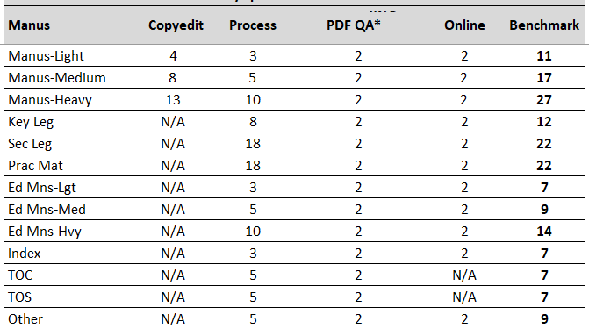
* PDF QA – Performed by Publishing editors prior ‘Online publishing’ and is the basis of Straive’s external quality. Not yet included in the current pub tracker.

III. Requirement details
3.1 Module 1: Dashboard

Primary Actor: LE (LN) and Straive

Pre-Conditions:
- Access in Jobtrack.

Post-Conditions:
- Update the count accordingly based on the latest status of jobs.

STP (PE, Coding (STP), STP TL)

Basic Flow:
- User logs in to the system.
- Page lands on My Jobs page by default.
- Dashboard should be shown at the top of My Jobs and All Jobs.
My Jobs – shows the count of jobs created/assigned by the logged-in user.
All Jobs – shows the count of all jobs
Late jobs– Jobs past due Target Press/Revised Press date* vs Actual Press
*Revised Press Date - if available
Due jobs – Due for today (Target Press/Revised Press)
Completed – No. of Jobs Completed the Posting Back to Stable Data
Cancelled – Cancelled Jobs

Coversheet (PE, Coding, Coding TL)

Basic Flow:
- User logs in to the system.
- Page lands on My Jobs page by default.
- Dashboard should be shown at the top of My Jobs and All Jobs.
My Jobs – shows the count of jobs created/assigned by the logged-in user.
All Jobs – shows the count of all jobs
Late – Online due date/ revised online due date vs Actual Online due date
Due jobs – Due for today (Online due date/ revised online due date)
Completed – No. of jobs completed in Online task
Cancelled – Cancelled Jobs

Manuscript (PE, LE (LN client))

Basic Flow:
- User logs in to the system.
- Page lands on My Jobs page by default.
- Dashboard should be shown at the top of My Jobs and All Jobs.
My Jobs – shows the count of jobs created/assigned by the logged-in user.
All Jobs – shows the count of all jobs
Late –

For Copyediting
Copyediting due date vs Actual Copyediting completion date

For Tasking
Target coversheet creation date vs Coversheet creation date
One day after Actual Copyediting completion date vs Coversheet creation date

Due jobs – Due for today

For Copyediting
Copyediting due date

For Tasking
Target coversheet creation date
One day after Actual Copyediting completion date

Completed –

For Copyediting
Completed on copyediting

For Tasking
Completed on coversheet

Cancelled – Cancelled Jobs

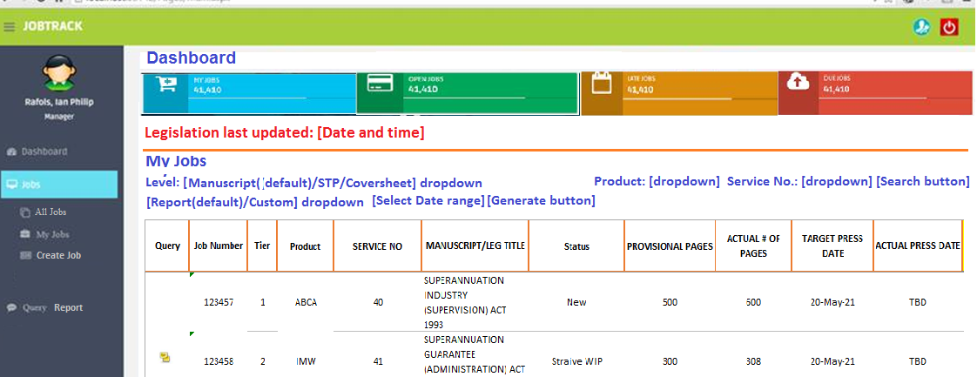

Note that the image above is for illustration purposes only. The developer can recommend on the UI.

Left pane tabs per Role:

Role | Dashboard | Product Database | All Jobs | My Jobs | Create Job | Create STP | Legislation | Remarks
LE | Y | N | Y | Y | Y | N | Y | See also legislation requirements below.
PE/PE_TL | Y | Y | Y | Y | N | Y | Y | Create Job for PE should be available in the My Jobs Page
Coding | Y | N | Y | Y | N | N | N
Coding_TL | Y | N | Y | Y | N | N | N | Should be able to start/done the task.
Coding (STP) | Y | N | Y | Y | N | N | N
Coding (STP)_TL | Y | N | Y | Y | N | N | N | Should be able to start/done the task.

3.1 Module 2: Jobs

Primary Actor: LE and Straive (All roles)

Pre-Conditions:
- Access in Jobtrack.

Post-Conditions:
- Update the count accordingly based on the latest status of jobs.

My Jobs

Basic Flow:
- User logs in to the system.
- Page lands on My Jobs page by default. Refer to each role below the specific columns for the required My Jobs table.
- There should be an option to search the desired service update (Product and Service no.).

- LE – created by the logged in user (Manuscript level)

Initially,
Attachment 1.
- PE – assigned to the logged in user (Manuscript; Coversheet level; STP level)

Attachment 2.
- Coding (STP) – assigned to the logged in user (STP level)

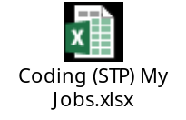
Attachment 3.
- Coding – assigned to the logged in user (Coversheet level)


Attachment 4.

- Clicking “Report” will generate the active view. Users can also generate specific information through custom report option.
- Reports will list all jobs based on the date selection.
- Reports can be exported to either Excel or csv.

All Jobs

Basic Flow:
- User logs in to the system.
- Click All Jobs at the left pane.
- There should be an option in the left pane to search the desired service update (Product and Service no.).

– Same information above (Attachments 1, 2, 3, & 4) but should display all jobs created by or assigned to the logged in user.

- Clicking “Report” will generate the active view. Users can also generate specific information through custom report option.
- Reports will list all jobs based on the date selection.
- LE – Per product
- Reports can be exported to either Excel or csv.

3.2 Module 3: Create Job

Primary Actor: LE and Straive (PE)

Pre-Conditions:
- LE and Straive (PE) should have the complete information of the job order.

Post-Conditions:
- Update the system accordingly based on the information provided by the LE and Straive (PE).

LE

Basic Flow:
- User logs in to the system
- Selects Create Job in the left pane.
- User inputs the following information:

Note: *Required fields
- Click Import button (for multiple Job creation).
- System will send notification to all individuals involved regarding the job order.
- Upon job posting, UI will be defaulted to My Jobs view with the new job created displayed at the top of the list.
- Click Post button (for single Job creation).
- System will send notification to all individuals involved regarding the job order. By default, the Job will be assigned to the publication owner. TL can also re-assign as necessary.
- Upon job posting, UI will be defaulted to My Jobs view with the new job created displayed at the top of the list.

Straive (PE) - Coversheet

Basic Flow:
- User logs in to the system.
- In My Jobs view, selects the appropriate box/es in column R. Please refer to Attachment 2 above.
- Clicking “Create Task Link” on any of the box selected will display the Job form below:

Note: *Required fields
Note: Create Task Link will be enabled once the copyedit task is completed as required.

- Click Post button.
- System will send notification to all individuals involved regarding the job order. The job will be available to Straive (Coding) team. It will be assigned by Coding TL to Coding member.
- Upon job posting, UI will be defaulted to My Jobs but the auto-generated coversheet no. will display for each selected task under “COVERSHEET NO.” column.

Straive (PE) - STP

Basic Flow:
- User logs in to the system.
- Select “Create STP” in the left page.
- In the right pane, user inputs the specific product and service no. to create STP Job for:

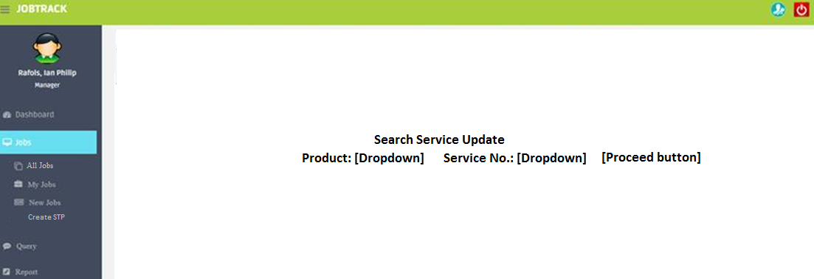

- Clicking “Proceed” will list all coversheets completed at “Coding” process.
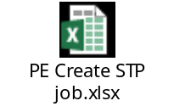

- Ticking the checkbox in the header will select all the coversheets. Otherwise, click appropriate check boxes individually.
- Clicking “+ LEGISLATION”, a pop-up window will display all the available legislation for the corresponding product and service no. with all check boxes ticked by default. User may deselect as necessary.
- Clicking “CREATE STP” button, below job form will display.



- Click Post button.
- System will send notification to all individuals involved regarding the job order. The job will be available to Straive (Coding - STP) team. It will be assigned by Coding TL to Coding member.
- Upon job posting, UI will display Attachment 2 above and update “STP” column (Y or TBD).

3.2 Module 2: Update Job

Primary Actor: LE and Straive (PE)

Pre-Conditions:
- Job order is already existing

Post-Conditions:
- Update the system accordingly based on the information provided by the LE and Straive (PE).
LE

Basic Flow:
- User will go to All/My Jobs to update a specific job.
- Upon clicking Edit link, enable all fields except for the ones not highlighted in yellow. Link will automatically change from "Edit" to "Update". User will click "Update" to save the changes.
- System will send notification to all individuals involved regarding the job update.
- Once the system saved the changes, a version control must be in place. A history log must also be incorporated in the system to keep track of the changes.

Straive (PE) –COVERSHEET

Basic Flow:
- User will go to All/My Jobs to update a specific job.
- Upon clicking Edit link, enable all fields except for the ones not highlighted in yellow. Link will automatically change from "Edit" to "Update". User will click "Update" to save the changes.
- System will send notification to all individuals involved regarding the job update.
- Once the system saved the changes, a version control must be in place. A history log must also be incorporated in the system to keep track of the changes.

Straive (PE) –STP

Basic Flow:
- User will go to All/My Jobs to update a specific job.
- Upon clicking Edit link, enable all fields except for the ones not highlighted in yellow. Link will automatically change from "Edit" to "Update". User will click "Update" to save the changes.
- System will send notification to all individuals involved regarding the job update.
- Once the system saved the changes, a version control must be in place. A history log must also be incorporated in the system to keep track of the changes.

  - Module 3: Query

Primary Actors: LE <-> Straive (PE)/Straive (PE) <-> Straive (Coding)/ Straive (PE) <-> Straive (Coding (STP))

Post-Conditions:
- Data can be retrieved or archived

All Jobs/My Jobs

LE - PE

Basic Flow:
- User will go to All/My Jobs to view or create query.
- Under “Query” column, click “View/Create” link and user will be redirected to the following:
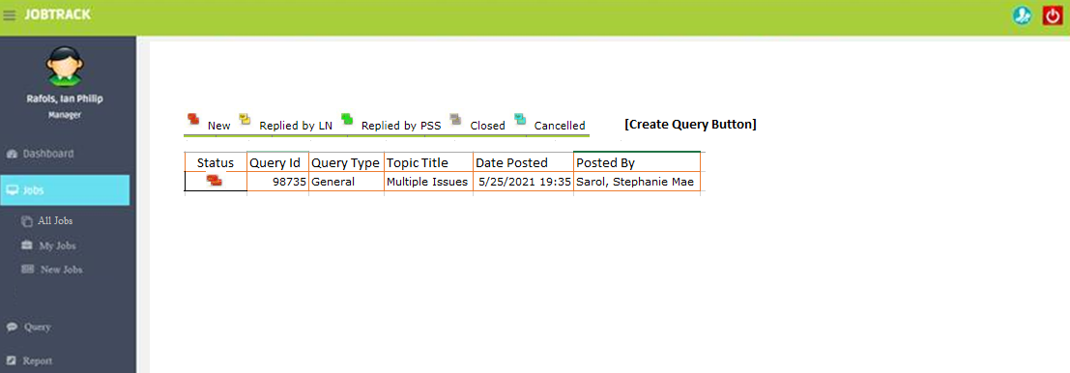

Note: All queries displayed should be between LE and PE only.

- Task will be automatically assigned based on the active task.
- Clicking “Query id” will go to complete query conversation arrange from latest to oldest response. Note: The user should have the option to go back to the query list if the user wishes to check out the other queries in the same job.
- Clicking “Create Query” button will go to a blank query form below.

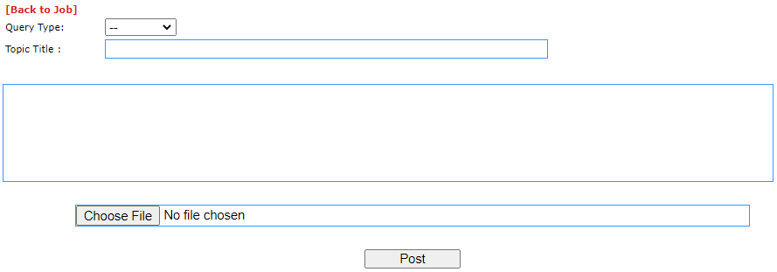

- Clicking “Post” button:
  - Will output below screenshot:

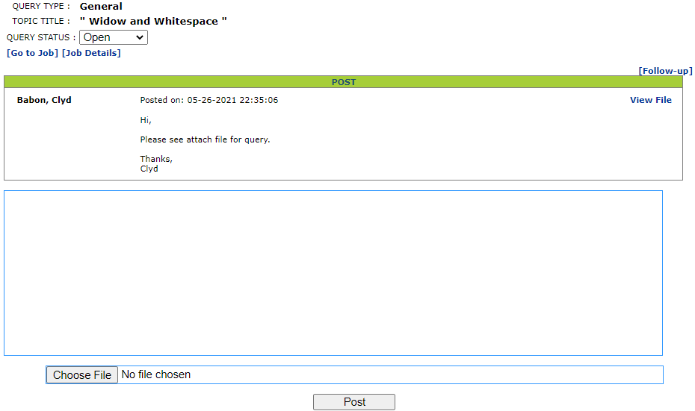

Query Status:

  - Open – Default upon posting a query.
  - Cancelled – TL/User who initiated the query can select this option.
  - Closed – TL/User who initiated the query can select this option.

  - Will display item#2 above with the new query posted showing at the top of the list.

PE - LE

Basic Flow:
- User will go to My Jobs – Manuscript level to view or create query.
- See items# 2 to #5 above.

Note: All queries displayed should be between LE and PE only.

PE - Coding

Basic Flow:
- User will go to My Jobs – Coversheet level to view or create query.
- See items# 2 to #5.

Note: All queries displayed should be between PE and Coding only.

PE – Coding (STP)

Basic Flow:
- User will go to My Jobs – STP level to view or create query.
- See items# 2 to #5.

Note: All queries displayed should be between PE and Coding (STP) only.

  - Module 4: Query Reports

Primary Actors: All users

Post-Conditions:
- Data can be retrieved or archived

LE/Straive Coding/Straive Coding (STP)

Basic Flow:

- Click “Query Reports” in the left pane.
- In the right pane, dropdown is defaulted to “My Queries” -replied/posted- of the logged in user. Should be arranged according to latest query date posted.
Dropdown menu:
  - My Queries
  - All Queries
  - Closed Queries
  - Open Queries
- Date Range selection and clicking “Search” button will display the corresponding queries.
- Clicking the icons of the desired report format will generate the data based from items#1-3 above.



Straive (PE)

Basic Flow:

- Click “Query Reports” in the left pane.
- In the right pane, dropdown is defaulted to “My Queries” -replied/posted- of the logged in user. Should be arranged according to latest query date posted.
Dropdown menu:
  - My Queries
  - All Queries
  - Closed Queries
  - Open Queries
- Under each category from item#2 dropdown menu above should have the following dropdown:
  - Manuscript – Queries between PE and LE
  - Coversheet – Queries between PE and Coding
  - STP – Queries between PE and Coding (STP)
- Date Range selection and clicking “Search” button will display the corresponding queries.
- Clicking the icons of the desired report format will generate the data based from items#1-3 above.

  - Module 5: History Trail

All changes or updates in a job will be recorded for tracking purposes. A job means any of the following:
- Coversheet No.
- Job No. (Manuscript)
- STP No.

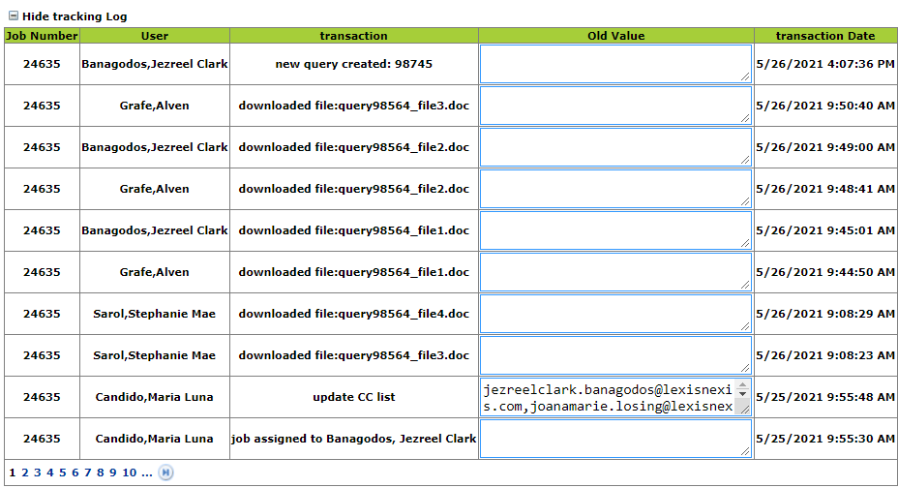

  - Module 6: Emails

- Job Creation

- New manuscript request notification

Subject: New manuscript - [Product]_[Service No.]_[Job no.] (example: New manuscript - ABCA_41_123456)

Body:
Date created:
Job No:
Tier:
Product:
Service No:
Manuscript/Leg Title:
Target Press Date:
Latup Attribution:
Date Received From Author:
Update Type:
Job Specific Instruction:
Task Type:

- New coversheet request notification

Subject: New coversheet - [Product]_[Service No.]_[Coversheet no.] (example: New coversheet - ABCA_41_123456)

Body:
Coversheet no.
Service No:
Task No:
Product:
Editor:
Charge Code
Target Press Date
Task Type
Guide cards
Location of manuscript/legislation\further instructions
Update type
General
Special Instruction

- New STP request notification

Subject: New STP - [Product]_[Service No.]_[STP no.] (example: New STP - ABCA_41_123456)

Body:
Target Press Date
Legislation
Filing Instruction
Dummy Filing 1
Dummy Filing 2
UECJ
PC1/PC2
STP
Sending Final Pages to Puddingburn
Posting Back to Stable Data
Updating of Ebinder

- Update Job

- Manuscript job updated notification
Subject: Job manuscript updated - [Product]_[Service No.]_[Job no.] (example: Job manuscript updated - ABCA_41_123456)

Body:

Following fields were updated:
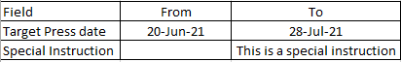

- Coversheet job updated notification
Subject: Job Coversheet updated - [Product]_[Service No.]_[Coversheet no.] (example: Job Coversheet updated - ABCA_41_123456)

Body:

Following fields were updated:

- STP job updated notification
Subject: Job STP updated - [Product]_[Service No.]_[STP no.] (example: Job STP updated - ABCA_41_123456)

Body:

Following fields were updated:

- Job Acceptance

- Manuscript job accepted notification
Subject: Job manuscript accepted - [Product]_[Service No.]_[Job no.] (example: Job manuscript accepted - ABCA_41_123456)

Body:
Job accepted on: [Date]
Job accepted by: [TL/PE]

- Coversheet job updated notification
Subject: Job Coversheet accepted - [Product]_[Service No.]_[Coversheet no.] (example: Job Coversheet accepted - ABCA_41_AAA 40_Task 1_FCPLEG)

Body:
Job accepted on: [Date]
Job accepted by: [TL]

- STP job accepted notification
Subject: Job STP accepted - [Product]_[Service No.]_[STP no.] (example: Job STP accepted - ABCA_41_123456)

Body:
Job accepted on: [Date]
Job accepted by: [TL]

- Query

- New Query posted
Recipients:
Subject: New Query Posted - [Product]_[Service No.]_[Job no.]_[Task] (example: New Query Posted - ABCA_41_123456_Manuscript)

Body:
Query Details
Topic Title: [Dropdown: Technical Issue - System Downtime/Technical Issue - JIRA/Manuscript/etc...]
Date of Query:
Query:
This is a query.
Attachment: [Y/N]

- Query Replied posted

Recipients:
Subject: Query Reply Posted - [Product]_[Service No.]_[Job no.]_[Task] (example: Query Reply Posted - ABCA_41_123456_Manuscript)

Body:
Query Details
Topic Title: [Dropdown: Technical Issue - System Downtime/Technical Issue - JIRA/Manuscript/etc...]
Date of Query: 05-28-2021
Query:
This is a query.

--------------------------------
Replied by: [User] [Time]
This is a reply to your query.

- Query Closed

Recipients:
Subject: Query Closed - [Product]_[Service No.]_[Job no.]_[Task] (example: Query Closed - ABCA_41_123456_Manuscript)

Body:
Query Details
Topic Title: [Dropdown: Technical Issue - System Downtime/Technical Issue - JIRA/Manuscript/etc...]
Date of Query: 05-28-2021
Closed by: [User who initiated the query.]

- Job completion notification

- Coversheet – XML Editing

Recipients:
Subject: Completed XML Editing - [Product]_[Service No.]_[Coversheet no.] (example: Completed XML Editing - ABCA_41_AAA 40_Task 1_FCPLEG)

Body: [Based on Ops Template]

- Coversheet – Online

Subject: Completed Online - [Product]_[Service No.]_[Coversheet no.] (example: Completed XML Editing - ABCA_41_AAA 40_Task 1_FCPLEG)

Body: [Based on Ops Template]

- STP

Recipients:
Subject: Completed STP - [Product]_[Service No.]_[Coversheet no.] (example: Completed XML Editing - ABCA_41_AAA 40_Task 1_FCPLEG)

Body: [Based on Ops Template]

- Job re/assigned notification (assignee)

Recipient: Assignee only/Assigned by
Subject: Job Assigned - [Product]_[Service No.]_[Coversheet no.] (example: Completed XML Editing - ABCA_41_AAA 40_Task 1_FCPLEG)

Body:
Date assigned:
Assigned to:
Assigned by:
Path:

- Subsequent Pass requested

Recipients:
Subject: Subsequent [1st] Pass Required - [Product]_[Service No.]_[Coversheet no.] (example: Subsequent 2nd Pass Required - ABCA_41_AAA 40_Task 1_FCPLEG)

Body: [Based on Ops Template]

- Subsequent Pass completion

Recipients:
Subject: Completed Subsequent [1st] Pass - [Product]_[Service No.]_[Coversheet no.] (example: Completed Subsequent 2nd Pass - ABCA_41_AAA 40_Task 1_FCPLEG)

Body: [Based on Ops Template]

- Proceed to Online

Recipients:
Subject: Proceed to Online - [Product]_[Service No.]_[Coversheet no.] (example: Proceed to Online - ABCA_41_AAA 40_Task 1_FCPLEG)

Body:

Coversheet [Coversheet No.] is approved and can proceed to online.

- Ready to Print notification

Recipients: ProductionPacific@lexisnexis.com.au (required)
Subject: Ready to Print - [Product]_[Service No] (example: Ready to Print - ABCA_41)

Body: [Based on Ops Template]

- Closed Job

- Manuscript

Recipients:
Subject: Sent to Print - [Product]_[Service No.] (example: Sent to Print - ABCA_41)

Body:

The following jobs were sent to print:

[Job No.] - [Manuscript title]

123556 - SUPERANNUATION INDUSTRY (SUPERVISION) REGULATIONS 1994

- STP

Recipients:
Subject: Service is closed - [Product]_[Service No]_[STP No.] (example: Service is closed - ABCA_41_STP1234)

Body:

STP job [STP no.] is closed.

  - Module 7: Product Database

This option is to load a spreadsheet and store the following details in a database:

The information above will be the auto-generated value in the fields in a job form. See sample below:

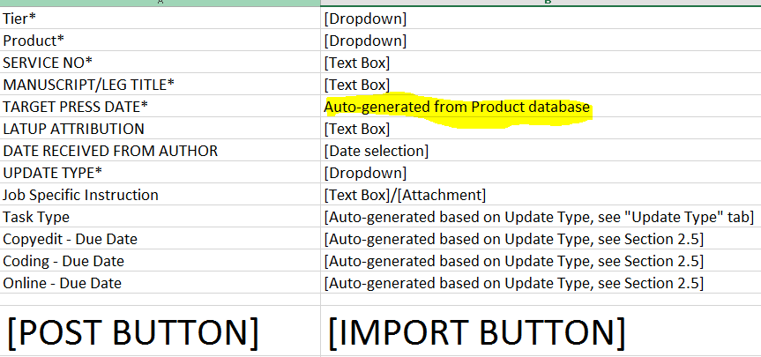

- modifiable
- need to display
- re-upload

  - Module 8: WORKFLOW AND COMMUNICATION BETWEEN LE and Straive and Straive and Coding

All communication between Straive and LE will be done via JobTrack.

    - Type of Links

S. No. | LE | PE | Action | Remarks
1 | [No action Possible] | [No action Possible] | Straive is working on the job
2 | [No action Possible] | [Proceed to Online] | Once PE is done with the PDF QA | These links should always be available at the same time whenever subsequent pass is submitted.  PE should click whichever is appropriate. The unselected link will automatically disappear and will reset to S. No. 1.
3 | [No action Possible] | [Subsequent Pass Request] | If PE requires some changes

    - How to work with the links

When you are ready to for the next step in the workflow:

1. Locate your pub under “My Jobs” or “Jobs”

2. Click on the link that best represents your need based on where you are with the service update.

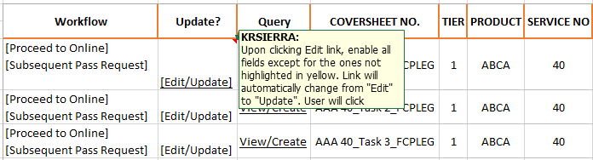

3. If a task has been delivered and you are pleased, you must close that task by selecting
either:
a. [[Proceed to Online] for Coding
4. If you are not pleased and required a new run, you must select either:
a. [Subsequent Pass Request]
5. When you click subsequent pass link, a window will pop-up in which you could add some comments or new instructions as well as attached a file. Examples:
a. “Please recomposed chapters 4,8, and 12 based on the flags in the attached pdf
file”
b. “Some changes were made to the data.”
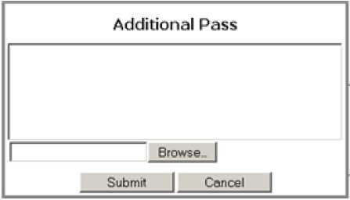
6. Once each link is selected, Jobtrack will send an e-mail confirming the action. See Section 3.6.

  - Module 9: Workbench

- Straive (Coding)
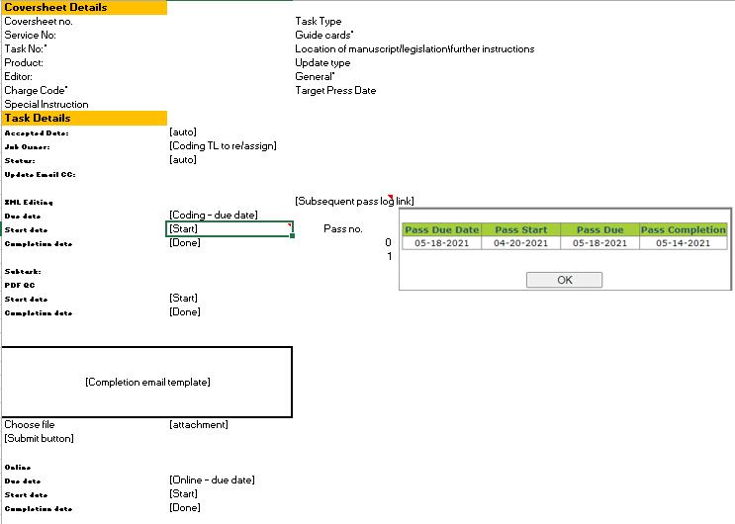
- Straive (Coding (STP))
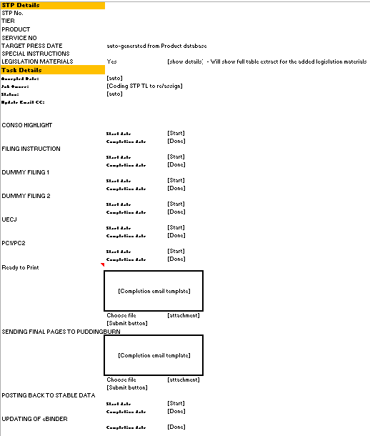
IV. Security Requirements
4.1 Authentication
Log on screen to the system will be provided.
4.2 Authorization
Authorization will be defined according to the type of users and modules to be accessed.
4.3 Access Level by Groups and Roles
User Level | Responsibilities and Access Rights
System Admin | Manages the system.  Provides access rights to the system – create, edit and delete
Manager/Leads | Create/Update job  Create/Reply on queries  Access to reports
Basic Users | Update job task fields  Create/Reply on queries  Create Jobs  Access to reports

V. Operational Requirements
5.1 The documentation for the Jobtrack will include the following:
Software User Manual – provides detailed documentation on how to use the Jobtrack System.

VI. Testing Requirements
  - Testing should be done initially by SPi and let LN know when it is ready for LN testing
  - SPi will provide a Certification environment for LN to perform testing before the tool goes live

LEGISLATION

I. Requirements
Module/Feature | General Overview | Objective
Legislation | Extract the latest data based from imported tracker. System should have the ability to validate the input against the active service update without ongoing STP. | To record available legislation for inclusion in STP job.

II. Requirement details
1. Legislation
Primary Actor: LE and Straive (Coding STP/TL)

Pre-Conditions:
- Access in Jobtrack

Post-Conditions:
- Record the system accordingly based on the information provided by the Straive TL.

TL

Basic Flow:
- In the left pane, user will click “Legislation”.
- In the right pane, following functions will be available:
  - Search – LE/Straive (TL/CodingSTP)
    - By Product and Service No.
  - Generate report – LE/Straive (TL/CodingSTP)
    - Date selection
  - Import - TL only
Extract the following information:
18_
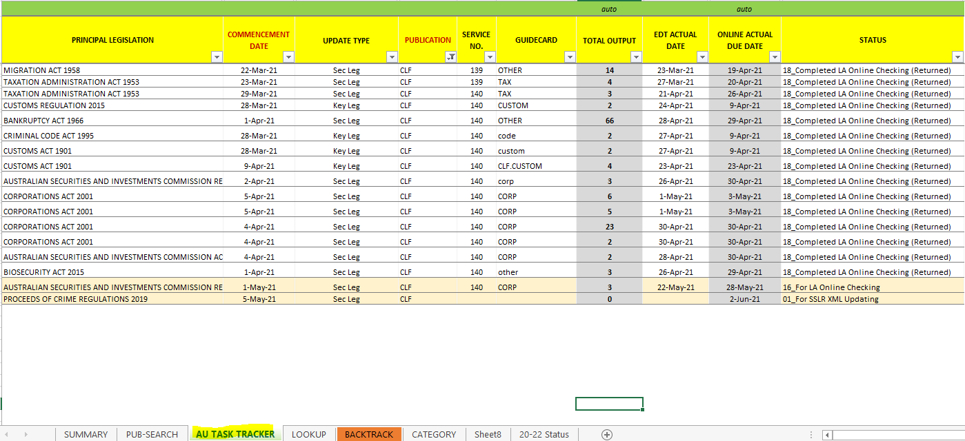
EXCEPT for entries with the following status:

- 20_---Cancelled
- 21_---Extracted
- 22_---Duplicate
- 23_---With conflict commentary
- 24_Not yet commenced

- Dashboard will be updated as of the latest time and date of import. See above.

